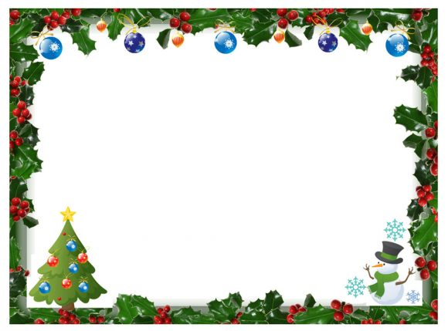

**We will be closed from**

**Saturday 19th December and reopen on Monday 4th January**

**Have A Very Merry Christmas and**

**Happy New Year**